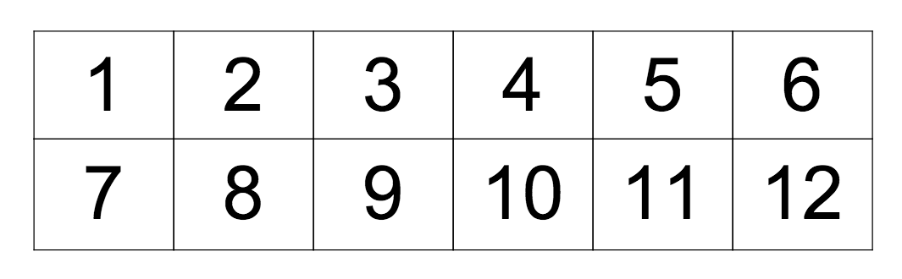
W i p e o u t !
W i p e o u t !

1 | 2 | 3 | 4 | 5 | 6
7 | 8 | 9 | 10 | 11 | 12

W i p e o u t !
Materials needed:
- 1-2 players
- Game board (or paper and pencil)
- Dice (2-3)
- 24 place markers (coins, found items)

How to Play:
- Each player will take turns rolling two (2) dice
- The roller can choose to add the two numbers on the dice together to find the sum, or to subtract one from another to find the difference += 7
- Students will then use a place marker to cover that space
- It is then the next player’s turn
- The object of the game is to cover every space on the chart. The first person to do so is the winner

Junior Extension:
- Students follow the same rules as above, but are able to use addition, subtraction, multiplication, and division in their answers x= 10

Intermediate Extension:
- Students follow the same rules as above, but are able to roll three (3) dice each time, and use multiple operations x+= 12
- To make the game more competitive, students could find as many possible solutions from one roll before ending their turn.

Overall Expectations: solve problems involving the addition and subtraction of single-digit whole numbers, using a variety of strategies.

Specific Expectations: solve problems involving the addition and subtraction of single-digit whole numbers, using a variety of mental strategies (e.g., one more than, one less than, counting on, counting back, doubles);

