Name: Boehme Cohort: B
Lesson Plan
Lesson Title: Introduction to Literature Circles Grade: 6/7 Date: Tuesday March 29, 2016
Subject/Strand: Literacy Unit: Literature Circles Location: Classroom Time: (length in minutes): 40 minutes
Lesson Plan Description (What are you teaching? How does it fit into the context of the unit? What are the big ideas/essential/enduring understandings?)
Students will be introduced to structure of literature circles. Teacher will model the Literature Circle Overview Sheet and read read part of The Hockey Sweater by Roch Carrier. The role of “Discussion Director” will be introduced and teacher will model the completion of the Discussion Director role sheet. Students will replicate their own copy of the Discussion Director worksheet.
If time allows students will be introduced to their group novels, and may meet in their groups to determine roles.
CURRICULUM CONNECTIONS
Ontario Curricular Overall Expectations (numbers from documents and details)
Reading
- read and demonstrate an understanding of a variety of literary, graphic, and informational texts, using a range of strategies to construct meaning;
Ontario Curricular Specific Expectations (numbers from documents and details) selected & listed from the Ont. Curriculum, refined when necessary, has verbs that are observable & measureable, has realistic number of expectations (1 to 3), have expectations that match assessment
Comprehension Strategies 1.3 identify a variety of reading comprehension strategies and use them appropriately before, during, and after reading to understand increasingly complex texts
Demonstrating Understanding 1.4 demonstrate understanding of increasingly complex texts by summarizing and explaining important ideas and citing relevant supporting details
Making Inferences/Interpreting Texts 1.5 develop interpretations about texts using stated and implied ideas to sup- port their interpretations
Extending Understanding 1.6 extend understanding of texts by connecting, comparing, and contrasting the ideas in them to their own knowledge, experience, and insights, to other familiar texts, and to the world around them
Analyzing Texts 1.7 analyze increasingly complex texts and explain how the different elements in them contribute to meaning (e.g., narrative: contribution of characters, setting, and plot to the theme; persuasive argument: the role of the summing-up paragraph in highlighting the most compelling points in the argument)
Responding to and Evaluating Texts 1.8 make judgements and draw conclusions about ideas in texts and cite stated or implied evidence from the text to support their views
Elements of Style 2.4 identify various elements of style – including voice, word choice, and the use of hyperbole, strong verbs, dialogue, and complex sentences – and explain how they help communicate meaning
Learning Goals Discuss with students: What will I be learning today? (clearly identify what students are expected to know and be able to do, in language that students can readily understand.)
Today I will learn…
- to use a Literature Circle Overview Sheet
- the role of the Discussion Director
- how to use the Discussion Director Role Sheet in a literature circle
ASSESSMENT and EVALUATION
Success Criteria Discuss with students: How will I know I have learned what I need to learn? (Clearly identify the criteria to assess student’s learning, as well as what evidence of learning students will provide to demonstrate their knowledge, skills and thinking, in language that students can readily understand).
I can: complete model examples of both the Literature Circle Overview Sheet and Discussion Director Role Sheet
I can: create success criteria for the Discussion Director Role
Assessment – How will I know students have learned what I intended?
Achievement Chart Categories (highlight/circle the ones that apply):
Knowledge and Understanding; Thinking; Communication; Application

Assessment For, As, Of Learning (Circle One) (Describe way(s) you and/or your students will assess.)
Assessment Mode  Written, Oral, Performance  (Write, Say, Do) | Assessment Strategy and Task for Students- What are the students doing to show their learning? e.g. turn and talk, role play/individual, cooperative, etc. |  | Assessment Tool - Instrument used to assess task and record learning e.g., rubric, checklist, observation sheet, turn/talk, role play etc.
Written | Completion of the task sheets |  | Checklist
CONSIDERATIONS FOR PLANNING
Prior Learning: Prior to this lesson, students will have
* Experience reading literature, summarizing, questioning, predicting, making inferences
Differentiation: Content, Process, Product, Environment, Assessment/Accommodations, Modifications
*Differentiation can occur for learning centre students by providing completed copies of the task sheets
Learning Skills/Work Habits Highlight/circle ones that are assessed: responsibility, organization, independent work, collaboration, initiative, self-regulation
Vocabulary (for word wall and/or to develop schema)
Literature Circle, Discussion Director, role, retell, relate, reflect

Resources and Materials /Technology Integration List ALL items necessary for delivery of the lesson. Include any attachments of student worksheets used and teacher support material that will support communication of instruction. Include the use of Information Technology (ICT) in your lesson plan where appropriate.
- Lesson guiding PowerPoint
- Document Camera
- Literature Circle Overview Sheets (29)
- Discussion Director Role Sheets (25)
- The Hockey Sweater by Roch Carrier
Learning Environment (grouping; transitions; physical set up)
Seated at desks, in Literature Circle groupings.

Cross Curricular Links
Writing
Classifying Ideas 1.4 sort and classify information for their writing in a variety of ways that allow them to view information from different perspectives and make connections between ideas
Three Part Lesson
Identify what the students are expected to think about or do. Write the lesson description with enough detail that another teacher could replicate the lesson without a personal discussion.
What Teachers Do: |  | What Students do:
Minds on: Motivational Hook/engagement /Introduction (5-15 min)
Establish a positive learning environment, connect to prior learning, set the context for learning, pre-determine key questions to guide lesson.
Time: 2:30 – 2:50 (Indicate time breakdown of instructional elements)  Teacher will introduce students to the Literature Circles through a short YouTube clip which provides an example.  https://www.youtube.com/watch?v=yVK9ZV-AinA  (End video when prompting question appears @ 2:55)  Teacher will pose this question to the class:  “What did you notice about the way the students shared, interacted, and behaved while discussing their novels?”  Teacher will contribute ideas to a mind map for use throughout the introductory lessons. |  | Students will watch video demonstrating Literature Circles  Students will respond orally to the video and contribute as a group to a Literature Circles mind map.  Responses might include:  - Sitting in a circle  - Responding to statements  - Asking questions  - Disagreeing respectfully and discussing
Action: During /Working on it (time given for each component, suggested 15-40 min)
Introduce new learning or extend/reinforce prior learning, provide opportunities for practice & application of learning.
Time: 2:50 – 3:15 (Indicate time breakdown of instructional elements)  Teacher will pass out duotangs to be used for the Literacy unit, as well as the Literature Circle Overview sheet.  Teacher will then turn to the Literature Circle Overview to be filled out using the document camera.  Teacher will read The Hockey Sweater aloud using the document camera.  Teacher will pass out the Discussion Director role sheets.  Teacher will explain the Discussion Director’s job:  The Discussion Director’s job is to create a list of questions involving BIG ideas that could be discussed with the group. These questions should be reflective and lead the discussion beyond the literal text.  “I wonder how… if… why… when… where…”  Teacher will complete a model of the task sheet. |  | 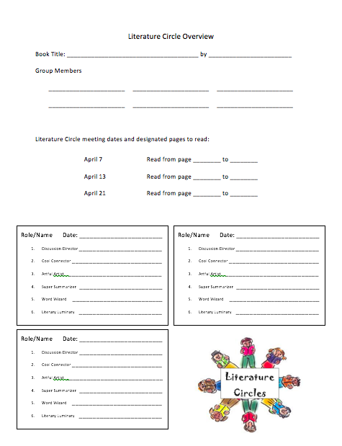  Students will collect a duotang and Literature Circle Overview sheet.  Students will follow along with the teacher to complete a model example using the short story The Hockey Sweater.  Students will listen to the story.  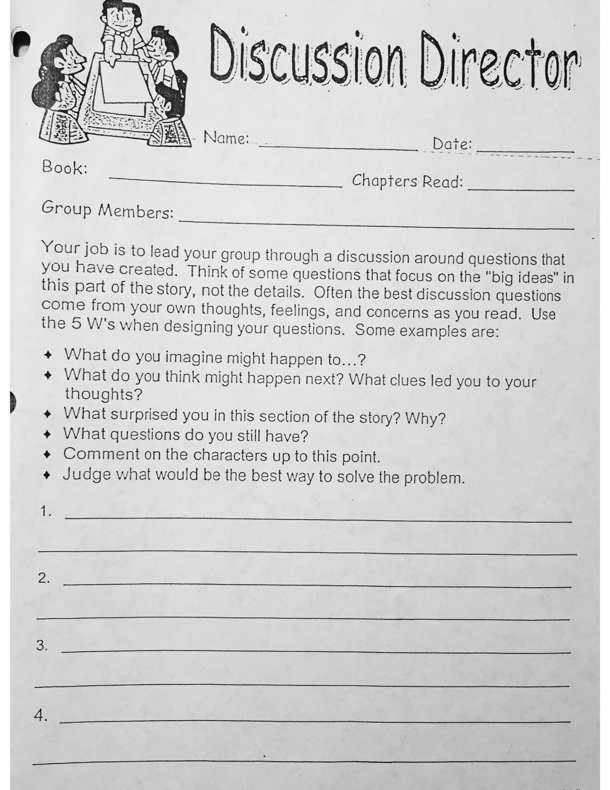  Students will complete a model example of the Discussion Director role sheet.  (This sheet will likely be modified for the lesson to better suit the class and expectations)  Students will store this model in their duotang for future reference.
Consolidation & Connection (Reflect and Connect) (5-15 min.)
Help students demonstrate what they have learned, provide opportunities for consolidation and reflection.
Time: 3:15 – 3:20 (Indicate time breakdown of instructional elements)  If time allows teacher will introduce students to their groups and novels – if not, they will be introduced at the beginning of the next class. |  | Students will gather in their novel study groups and determine their roles for the first Literature Circle by filling out the Literature Circle Overview.
Extension Activities/Next Steps (where will this lesson lead to next)
The next lesson will introduce the Cool Connector Role and role sheet, the 8-box system, and persuasive writing
Personal Reflection (what went well, what would I change, what will I have to consider in my next lesson for this subject/topic)
The Lesson:

The Teacher:

